**Pass task 10.1: Unit Testing**

**Part 1**

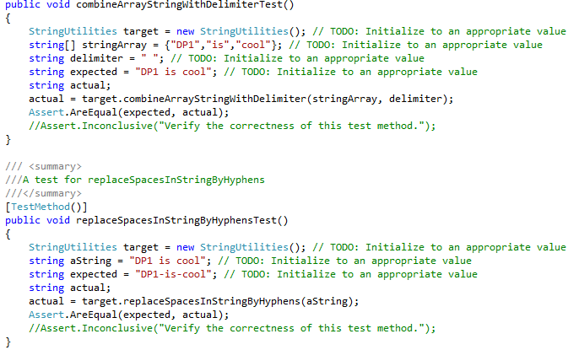

Figure (1) Both test method for combineArrayStringWithDelimiter function and replaceSpacesInStringByHyphens function

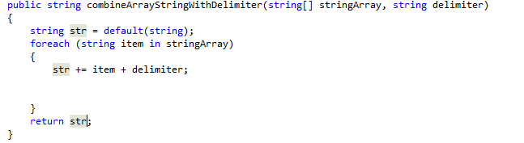

Figure (2) combineArrayStringWithDelimiter function before fixing it to meet the test criteria.

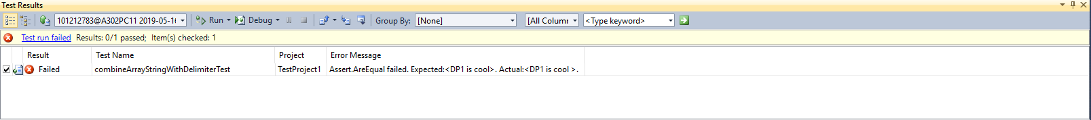

Figure (3) Test error for combineArrayStringWithDelimiter function

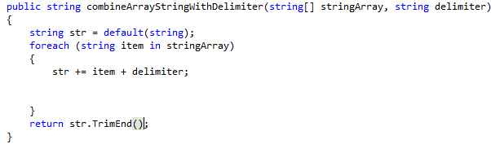

Figure (4) combineArrayStringWithDelimiter function after fixing it to meet the test criteria.

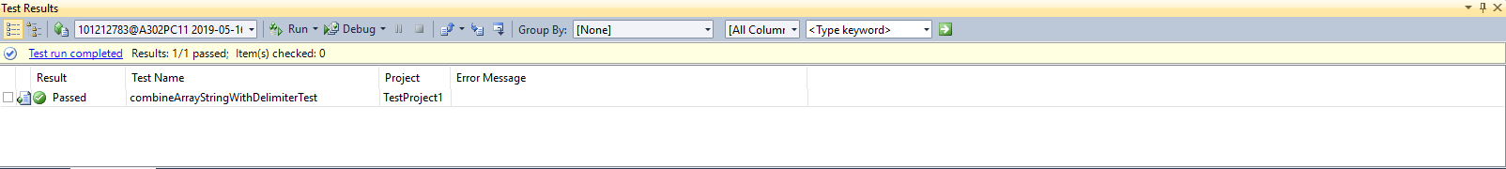

Figure (5) Test passed for combineArrayStringWithDelimiter function

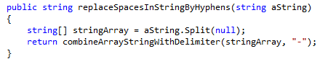

Figure (6) replaceSpacesInStringByHyphens function before fixing it to meet the test criteria.

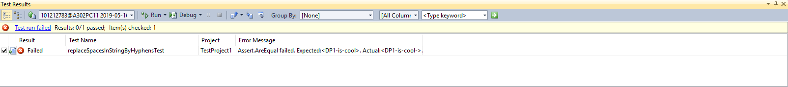

Figure (7) Test error for replaceSpacesInStringByHyphens function

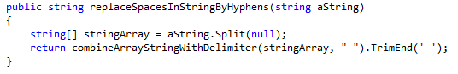

Figure (8) replaceSpacesInStringByHyphens function after fixing it to meet the test criteria.

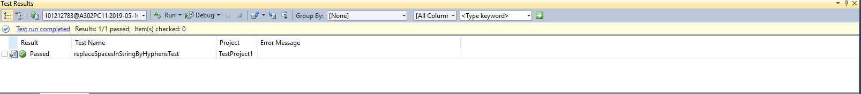

Figure (9) Test passed for replaceSpacesInStringByHyphens function

**Part 2**

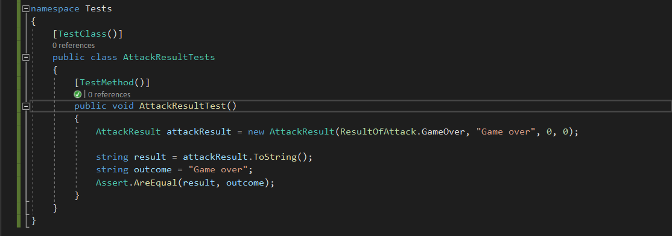

Figure (10) Unit testing for AttackResult function

For the battleship testing I decided to test whether the AttackResult function is working as intended. In the unit testing class, I called the AttackResult function and assigned the values into a new variable called attackResult where the game is Over so ResultOfAttack.GameOver is passed into the function value and the string “Game over” will appear. I then passed on the value of attackResult into a new string variable called result and added the .ToString() function so that it will convert the values into a string. I then created another string variable called outcome and assigned the string value with “Game over” this is so that I can compare the result of the function and the expected outcome that the function should produce. I then use Assert.AreEqual function to compare both result and outcome. If both variables are equal, then the test is a success otherwise the test is a failure. The result of the test is a success as it is shown the figure (11).

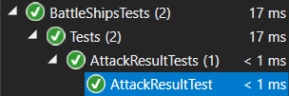

Figure (11) Test success for AttackResultTest Unit testing.